
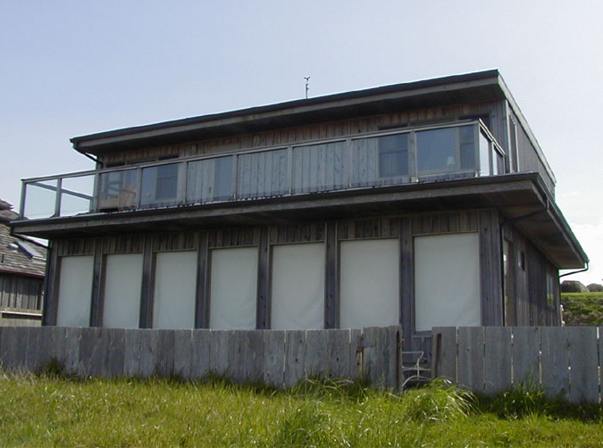
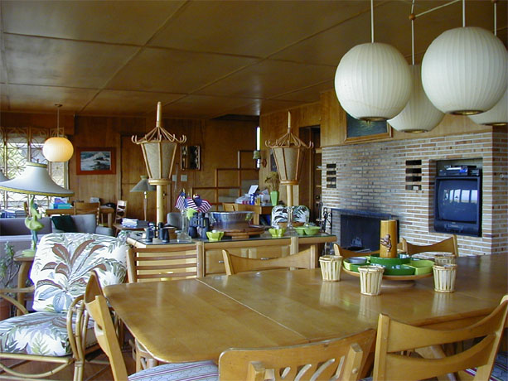
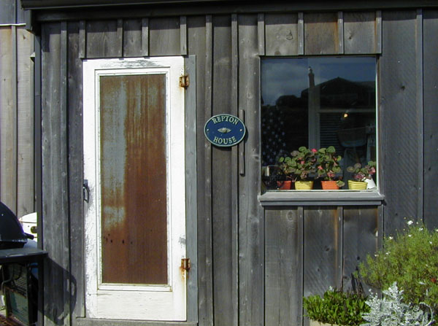
.
Beauty. Stunning Views.

Ocean Front Property
Fantastic ocean view, open and airy, you must see it to really appreciate the ambiance and setting. Designed for family living with dramatic open areas and plenty of windows and light. Only minutes, by foot, to pristine beaches and just down the road from some of the most unique shops in the state.

10224 SW Beach Lane • Seaside, OR 97231
Don’t let this one pass you by…
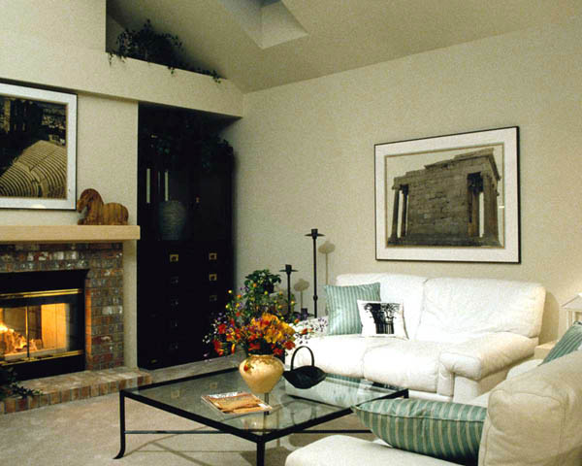
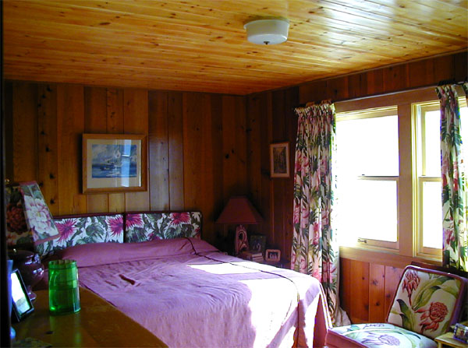
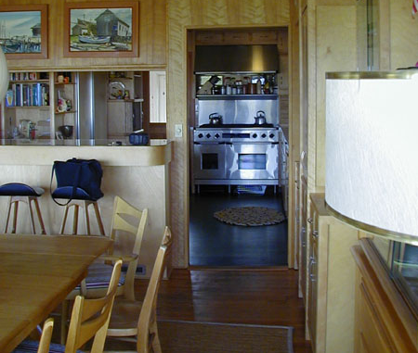
Fabulous space, great location, only 20 minutes from city center and right on the beach. Whether you’re interested in antiquing, kite flying, deep-sea fishing or beach combing; this is the ideal vacation spot for the whole family.

- 3200 square feet
- 4 bedrooms, 3.5 bathrooms
- Large, finished basement, perfect for family activities
- Vaulted ceilings
- Hardwood floors with mahogany inlay
- Custom gourmet kitchen with Sub-Zero refrigerator & double ovens
- Granite countertops
- Wood and glass cabinetry
- Formal dining area, custom designed home office space

For a personal showing, please call 800-555-1212
Or experience a virtual tour on our website:

www.yourwebaddress.com

Agent Name
Agent Title

(800) 555-1212 phone 1
(800) 555-1212 phone 2
(800) 555-1212 phone 3
email@youremail.com
www.yourwebaddress.com

LOGO

