
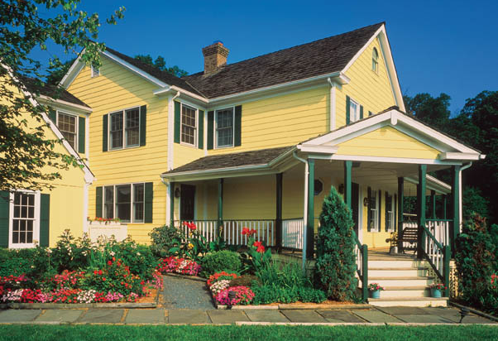
his beautifully refurbished home is the perfect country retreat. Only 20 minutes from city center, situated

T
raditional charm
10224 SW River Lane • Portland, OR 97231

For a
personal
showing,
please call
800-555-1212
or experience
a virtual tour
on our website:
www.yourweb.com

T
on 2.5 acres of prime farmland. Sit on the wrap-around deck and soak in the dramatic valley views. Designed for family living, it features:

• 4200 square feet
• 5 bedrooms; spacious
master with fireplace
$468,000
• 3.5 bathrooms
Don’t miss
out
on
this
one
• Custom gourmet kitchen
with fireplace, granite
counters, and updated
appliances (see back details)
• Formal dining area
• Large, finished basement
perfect for family
activities
• Custom designed home
office space
• Beautiful pine floors
• Professionally landscaped
(see back details)

LOGO

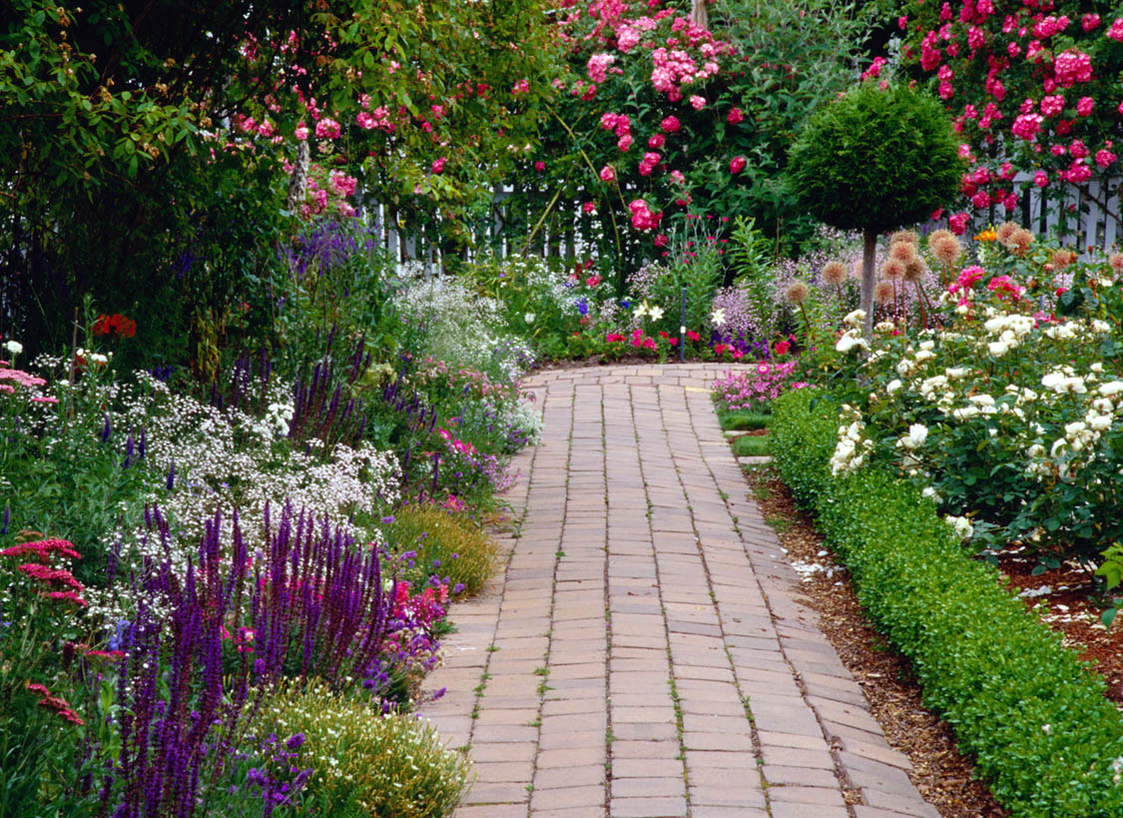

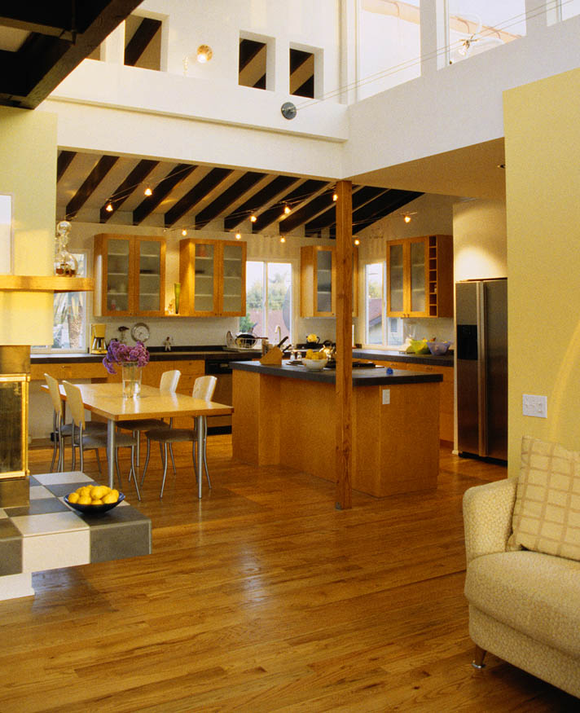
odern Flair
• Warm wood stove
• Custom pine flooring
• Vaulted wood beam
ceilings

• Sub-Zero refrigerator
• Granite countertops
• Wood and glass cabinetry
Brand new kitchen and family room addition, features dramatic open space with plenty of windows and light.

Custom gourmet features throughout.
You will fall in love with the romantic English style garden.

G
ardener’s Paradise
• Vintage roses
and perennials
• Charming brick path
and picket fence

Agent Name
(000) 555-1212 direct
(000) 555-1212 cell
email@youremail.com
www.yourwebsite.com
M

